Fox Valley United Way partners with FamilyWize to provide access to affordable prescription medications in order to ensure greater health and financial stability to community members.
The FamilyWize Prescription Savings Card:
- Is free for everyone – it’s like a coupon that you can use as often as you want.
- Reduces cost – just show the card every time to get the lowest prices, whether it be FamilyWize, insurance or retail price.
- Is easy to use with no registration or eligibility requirements.
- Covers FDA approved prescription medications.
- Saves an average of 45% on prescriptions.
- Accepted at major chain pharmacies nationwide
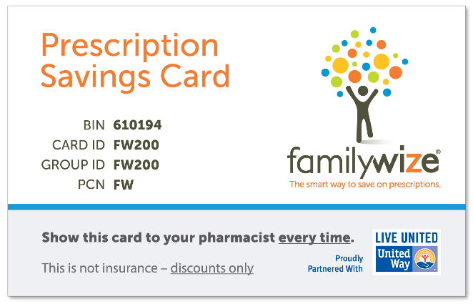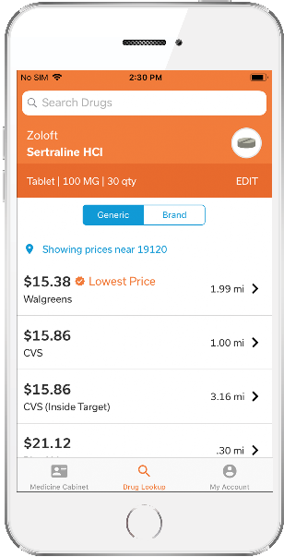
How do I get a card?
- Contact United Way at: ________
- Download and print a card
- Text "family" to 700700 to receive a card on your phone (Message and data rates may apply. FamilyWize Terms and Privacy)
- Download the FamilyWize app from the Apple App Store or Google Play.
Drug Price LookUp Tool:
- You are able to see the FamilyWize price of your prescription(s) by either going to familywize.org or by downloading the free FamilyWize app. Simply enter your drug name, dosage and zip code to find the lowest price within a 10 mile radius.

HOW IT WORKS
FamilyWize negotiates fair drug prices directly with major pharmacies like CVS, Walmart, and Walgreens. We pass the savings onto our members, free of charge.
To start saving with FamilyWize, a member just needs to show the savings card to their local pharmacist whenever they fill a prescription at a participating pharmacy. The discount will be automatically applied to the retail price of the drug.
Members can use their card as often as they want. Cards do not expire. Cards may also be used for family members’ prescriptions and shared with friends.

